ITD 1983 (Rev. 10-15-10) **Local Public Agency's Certificate Of**

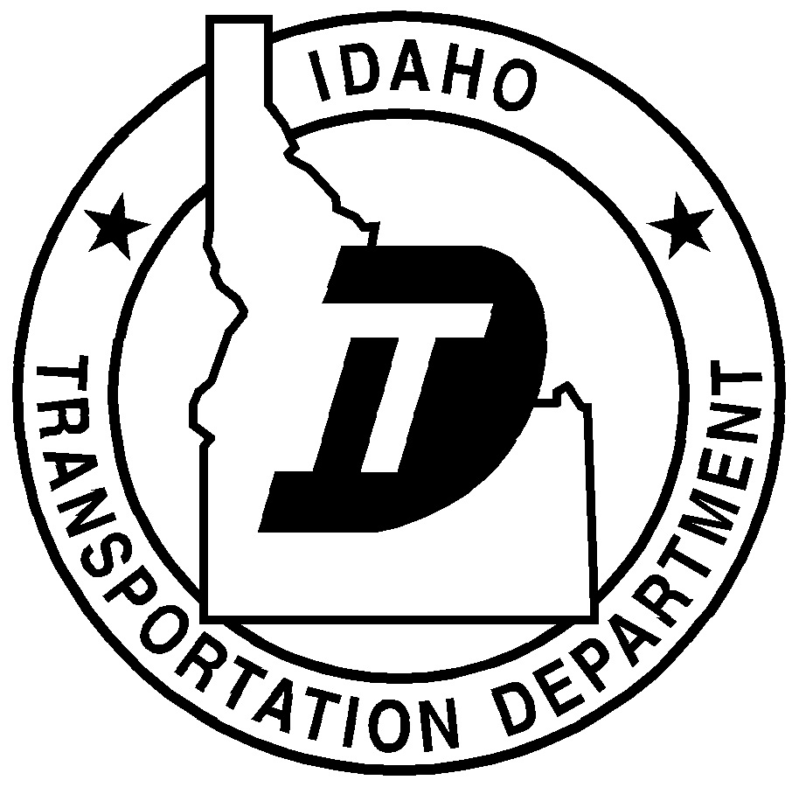

itd.idaho.gov **Completion Of Right-Of-Way Activities**

Idaho Transportation Department

|  |  |  |
| --- | --- | --- |
| Key Number | Project Number | Project Name |
|  |  |  |
| Local Public Agency | | |
|  | | |

**Complete the applicable section below and the Certification section.**

**Right of Way is Not Required**

All work will be done within the existing right of way

No utilities are involved in this project

Utilities are impacted and agreements are in place. Number of Utilities

**Right of Way is Required**

Number of ownerships acquired       Total amount paid $

Number of parcels in condemnation or pending final settlement

Number of Relocations

No utilities are involved in this project

Utilities are impacted and agreements are in place. Number of Utilities

**Certification**

I hereby certify that all acquisitions and relocations, if any, were performed in accordance with our assurances to comply with state and federal laws and regulations related to the Uniform Relocation Assistance and Real Property Acquisition Policies Act of 1970 and amendments thereto.

It is further certified that in all cases where the real property rights were obtained through donation, that the property owner(s) was fully informed of the right to receive just compensation and the owner has released our agency from its obligation to appraise the property in the event that the estimated value may exceed $5,000.00.

|  |  |  |  |  |
| --- | --- | --- | --- | --- |
| Agency Contact's Name (Printed) | Phone Number | | E-Mail Address | |
|  |  | |  | |
| Attester's Signature (Clerk or Secretary) | Date | Chairman, President, or Mayor's Signature | | Date |
|  |  |  | |  |