 ITD 0866 (Rev.10-14)

Wipe Test Kit
For Nuclear Density Gauge

Idaho Transportation Department
HQ Central Lab
PO Box 7129
Boise ID 83707

Rod Source Only
Internal Source Only

District Number | City
Gauge Make |  | Model
Gauge Serial Number
Isotope |  | Quantity
Source Serial Number
Test Date
Tester's Name

Instructions for Rod Source Only
- Turn the gauge on its side.
- Remove the swab from the plastic container, moisten it, (not wet) and wipe around scraper ring and shutterblock area. It will not be necessary to extend the source rod.
- Put the swab directly back into the plastic container and seal.
- Take a survey meter and do a quick check to see if any sign of radiation is present on the swab. If you get a reading from the swab, seal off the area and start emergency response procedures.
- If no reading is indicated above the normal background count, then sign, date, and mail back to HQ Central Lab.

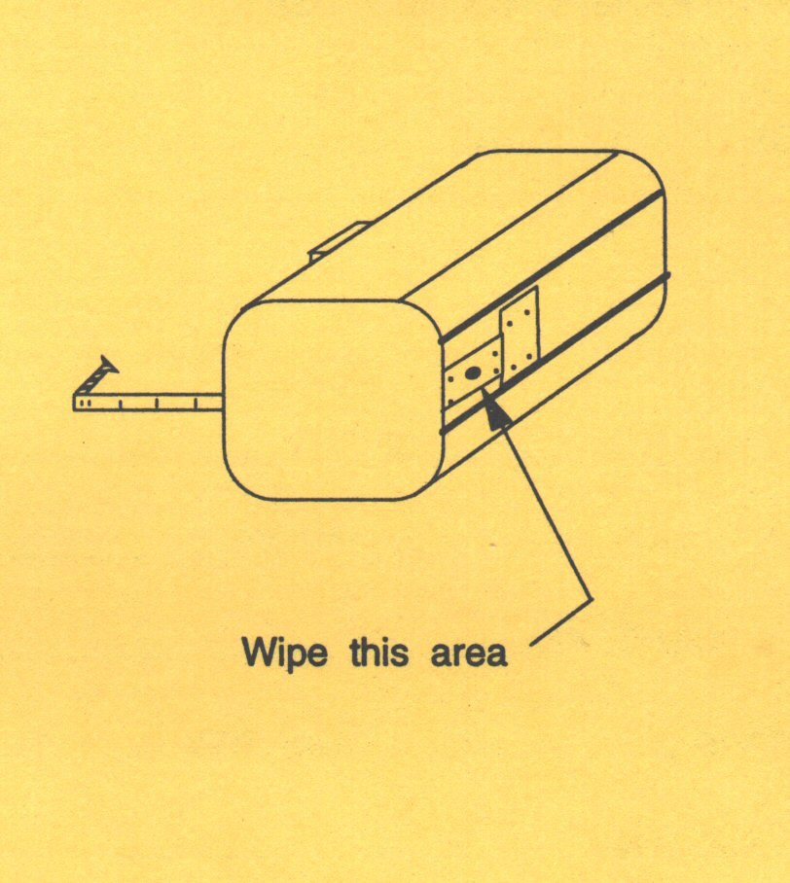
Rod Source

Instructions for Internal Source Only
- Turn OFF power to gauge.
- Loosen Screws and remove scaler.
- Locate the source cover plate or label; it will be inside the gauge on the bottom.
- Remove the swab from the container, moisten it, (not wet) and wipe around this area and the red dot on CPN'S.
- Put the swab directly back into the plastic container and seal.
- Replace scaler and fasten.
- Take a survey meter and do a quick check to see if any sign of radiation is present on the swab. If you get a reading from the swab, seal off the area and start emergency response procedures.
- If no reading is indicated above the normal background count, then sign, date, and mail back to HQ Central Lab.

Internal Source
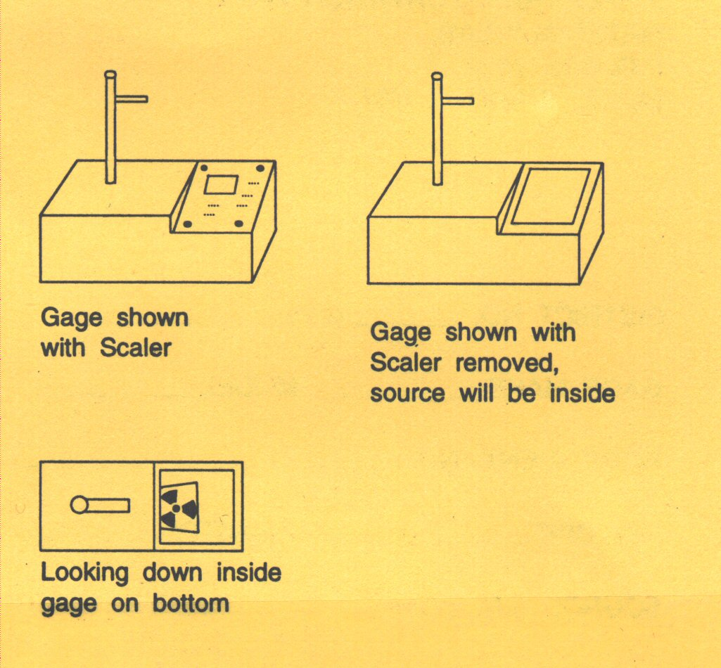
Gauge shown with Scaler removed, source will be inside
Gauge shown with Scaler

Looking down inside gauge on bottom

