 | Outdoor Advertising Sign Application and Permit  Idaho Transportation Department | ITD 1850 (Rev. 04-18)  itd.idaho.gov
Complete all sections on this page, attach the $10.00 fee, site plan, a drawing of the sign and all required documents (see below). Submit to the Idaho Transportation Department District Office nearest the sign's location (shown on Page 2).
Required Documents and Fees (Application will be returned if all of the following documents and fees are not included) ITD reserves the right to request additional information
Copy of building permit or other city or county written permission  Detailed site plan of the proposed display location  Evidence of property owner's consent or copy of the sign site lease |  |  | A plan detail of the proposed sign (configuration of the display)  Copy of the last deed of record  $10.00 Non-refundable fee
Sign Application is for (choose one)
Off-Premise Sign Community Official Sign Religious Notice Directional Other
Applicant’s Name (type or print) | Applicant’s Signature |  |  |  | Contact Phone Number
Mailing Address (for permits, letters and announcements) |  | City |  | State | Zip Code
Applicant Represents One or More of the Following
Sign Owner Sign Company Community Church Non-Profit Organization Other

Sign Site Land Owner's Consent – Complete this section or if a sign company, attach a copy of the lease
Sign Site Land Owner's Name (printed) | Sign Site Land Owner's Signature Granting Consent for Sign and Permission for ITD to Enter Property for Sign Inspection or Removal |  | Sign Site Landowner's Phone No.(s)
Sign Site Land Owner's Mailing Address |  | City | State | Zip Code

Sign Location, Sign Structure, Sign Face, Illumination Information
Location | Highway Number |  | Nearest Milepost |  | Nearest Cross Street(s)
Location | Sign Site Address (street number and name) |  |  |  | City |  |  |  |  | State | Zip Code
Location | Site Will Observe 20 Foot Structure Setback Requirement |  |  |  |  |  | If No, Provide Deed Number (required)
Location | Yes No
Sign Face Description | Sign Face Height | Sign Face Width |  | Area in Square Feet  (max 1000 sq. ft.) |  | Sign(s) Will be Illuminated |  |  | Type of illumination (describe fully, attach separate sheet if necessary)
Sign Face Description |  |  |  |  |  | Yes No
Sign Face Description | Face(s) Single-face V-Type Back-to-Back Tri-vision (MMS) Electronic Variable (LED or MMS)
Sign Structure | Height of Overall Structure (including Face) |  | Distance From Bottom of Sign Face to Ground |  | Sign is in Place - If Yes, Date Erected |  |  | Type of Sign Structure
Sign Structure |  |  |  |  | Yes  No |  |  | Monopole Steel Beams Wood  Other

Commercial Use (Describe qualifying business activity on the sign site)
Describe Commercial Use (business on site) | Business Owner name | Telephone

Zoning Authority Affidavit (for authorized use only )
The sign site described above is zoned: | Commercial |  | Industrial | Not Zoned
County the Sign Will Be Located Within |  | City the Sign Will Be Located Within |  |  | Impact Area the Sign Will Be Located Within
I hereby certify that the sign site described above is zoned as specified above.
Authorized Zoning Representative’s Name (printed) |  | Authorized Representative’s Signature |  |  |  | Telephone Number | Date

-- ITD Official Use Only --
1. Fees Paid | Check Number |  | Cash Amount |  |  | 2. District Receiving Payment |  |  | Date District Received | 3. Date Application Returned to Applicant
Check Cash
4. Application/Sign Number |  | 5. Sign Owner Number |  | 6. Route |  |  | 7. Street Name |  |  |  | 8. Milepost
 |  |  |  |  |  |  |  |  |  |  | . L R
9. Approve Deny By District Sign Agent
District Sign Agent’s Signature |  |  |  |  | Date |  |  | Headquarters Reviewer’s Signature |  |  |  | Date

Idaho Transportation Department
District Offices
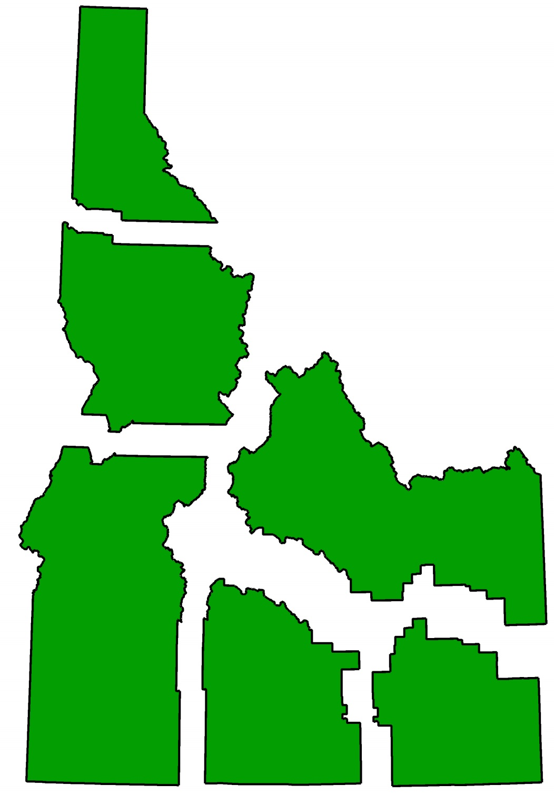
District 6 206 N Yellowstone
PO Box 97
Rigby ID 83442
(208) 745-7781

5
District 5 5151 South 5th
Pocatello ID 83201
(208) 239-3300

4
2
1
6
District 4 216 Date Street
Shoshone ID 83352
(208) 886-7800

District 3 8150 Chinden Blvd
PO Box 8028
Boise ID 83707
(208) 334-8300

3
District 2 2600 Frontage Rd
PO Box 837
Lewiston ID 83501
(208) 799-5090

District 1 600 W. Prairie
Coeur d'Alene ID 83815
(208) 772-1200

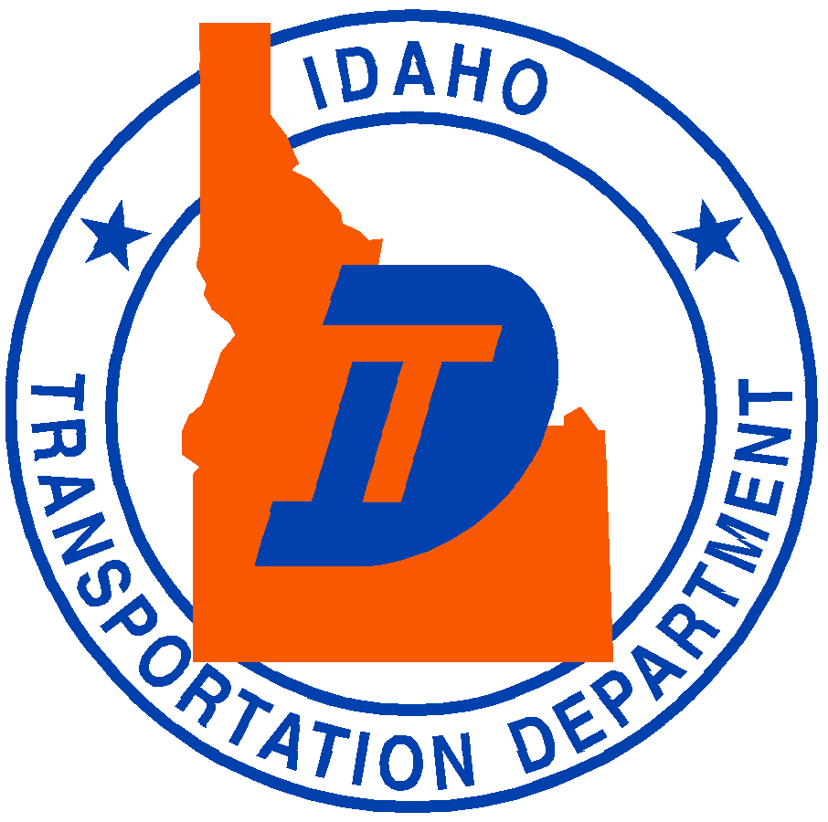
Idaho Transportation Department Headquarters

PO Box 7129
3311 State St
Boise, ID 83707
(208) 334-8506

