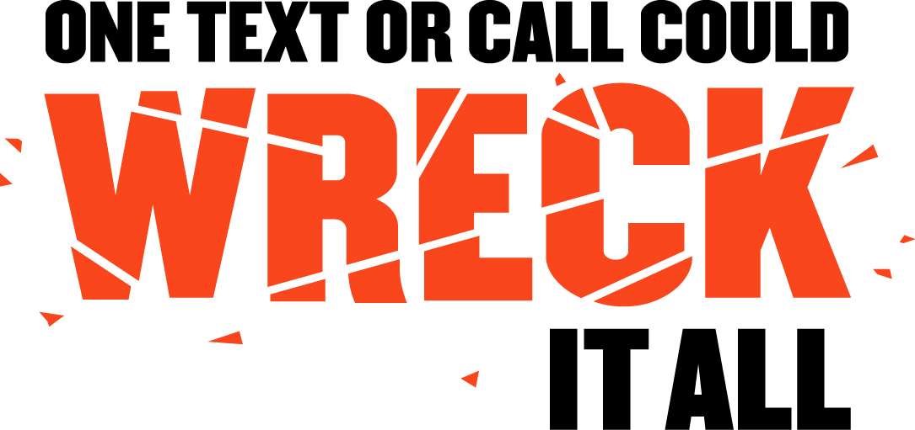
SAMPLE LETTER FROM SCHOOL OFFICIALS
TO PARENTS/GUARDIANS REGARDING
PARENT-TEEN DRIVING CONTRACT

[DATE]

Dear Parent/Guardian,

Did you know that motor vehicle crashes are the leading cause of death for teens in the United States?

We all talk to our teens about the dangers of drunk driving and the importance of wearing seat belts. But there is another traffic safety issue we must make our children aware of so they can stay safe behind the wheel: distracted driving.

In 2013, 3,154 people were killed and an estimated 424,000 were injured in motor vehicle crashes. Sadly, our youngest and most inexperienced drivers are often the most at risk.
Today I’m writing to ask you to sit down and discuss this important issue with your teens and have them sign the attached Parent-Teen Driving Contract. It’s a conversation that could save their life!

Distracted driving comes in many forms. It can include electronic distractions, like navigation systems and cell phones, or more conventional distractions, like interacting with passengers and eating.

Unfortunately, texting is the most dangerous of all distractions because it involves manual, visual and cognitive distraction simultaneously. Sending or reading a text takes your eyes off the road for 4.6 seconds. At 55 mph, that’s like driving the length of an entire football field blindfolded.

Student safety is our No. 1 priority at [SCHOOL], and we are committed to including appropriate driver education in our curriculum. However, we need the support of parents and family members to supplement this effort.

So, I’m asking you to join with me and encourage your teen to pay attention to the road at all times. Remind them that “One Text or Call Could Wreck It All.”

If you need any additional information or have any questions, please feel free to contact me or my staff.

Sincerely,

NAME
TITLE (Principal, Superintendent, PTA President, or School Board President, etc)

